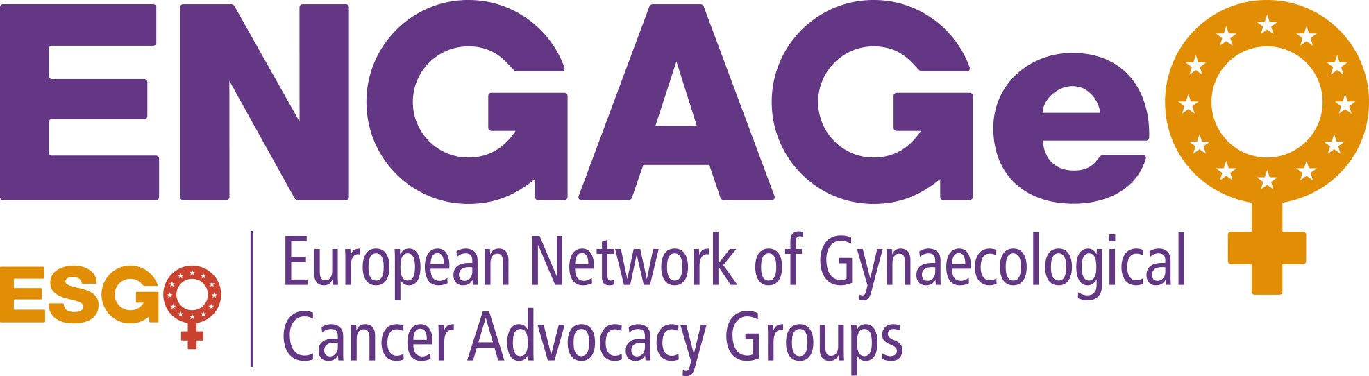

Background Media Information

European Network of Gynaecological Cancer

Advocacy Groups (ENGAGe)

The Voice of Gynecologic Oncology Patients in Europe

About ENGAGe

Established in 2012 by ESGO, ENGAGe is a network of European patient advocacy groups representing all gynaecological cancers particularly (ovary, endometrial, cervix, vulva and rare cancers).

As the only umbrella organization in Europe, ENGAGe strives to facilitate patient education and awareness about gynecologic cancers in general, as well as to involve patient advocacy groups to evaluate various aspects in the development process of the ESGO clinical practice guidelines.

ENGAGe is the voice of gynecologic cancer patients in Europe.
With over 50 gynecologic cancer advocacy groups in 25 countries, ENGAGe is Europe’s largest network.

ENGAGe focuses its efforts on 6 primary objectives:

- Facilitating the development of national gynaecological cancer patient groups in Europe and the networking and collaboration between them.
- Disseminating information and sharing best practices to empower patient groups and improving the quality of care across Europe.
- Building public awareness and mobilizing best care for women with gynecologic cancers at national and European levels.
- Increasing patient representation in ESGO activities by education on current research and health policy.
- Advocating patient care policies, practices, and access to appropriate care at both national and European levels.
- Educating and building the capacity of patient groups, and facilitating their communication with health professionals, the public and health decision makers.

Advancing Knowledge and Raising Awareness

To support its aims ENGAGe organizes a 3-day patient advocacy seminar mainly during the ESGO biennial Gynaecological Oncology Congress, facilitates patient education and awareness activities in collaboration with its network of members and partners, publishes essential gynecologic cancers factsheets and special leaflets on diverse topics, available now in 15 languages, as well as conducts surveys to evaluate the overall awareness of gynecologic cancer patients and quality of care.

The ENGAGe Patient Advocacy Seminars are a platform for leaders of patient groups to share and exchange knowledge, foster collaborations and empower themselves with information that will help them tackle the issues they face back home.
The up-coming Seminar at the ESGO 2019 Congress in Athens will include an exclusive program featuring new formats and opportunities, including round table discussions with experts, scientific presentations by key opinion leaders on treatment and care, a discussion forum on best practices, patient advocates’ presentations at the ESGO congress.
ENGAGe developed recently the Clinical Trial knowledge Project in cooperation with ENGOT, ESGO’s European Network for Gynaecological Trial Groups, in order to incorporate the patient perspective in the design of clinical trials.
Earlier this year ENGAGe encouraged the launch of public awareness campaigns in Poland and Czech Republic to improve prevention and care for women, followed by a national public survey to evaluate women’s knowledge on these topics.
This year marks the launch of the ESGO-ENGAGe initiative of the first ever World Gynaecological Oncology awareness Day, which will be held every year on Sep 20th.

EEG Members

Birthe Lemley, Denmark

Mihaela-Simona Ene, Romania

Karina Dahl Steffensen, Denmark

Dina Kurdiani, Georgia

ENGAGe Executive Group (EEG) 2016-2019

Co-Chair
Murat Gultekin, Turkey

Co-Chair
Esra Urkmez, USA

Perceptions, Expectations, and Experiences of Gynecologic Cancer Patients:
The Pan-European ESGO-ENGAGe Survey Highlights

ESGO-ENGAGe led a cross-national survey during 2017 to capture the overall perception and unmet needs of gynecological cancer patients. Data was collected from 1436 patients in 10 European countries comprising the Czech Republic, Denmark, Germany, the UK, Greece, Hungary, Poland, Serbia, Spain, and Turkey.

The survey outcomes indicate a relatively high level of unawareness among cancer patients regarding their cancer type diagnosis/prevention and screening tests.

Early detection plays a crucial role in the fight against cancer and it requires population-based screening programs and greater awareness of the early signs and symptoms of cancer. The findings of the study show that the percentage of the patients diagnosed as a result of routine screening is low (24.7%), confirming an area of unmet need to further encourage women to understand the importance of routine checkups in diagnosing gynecologic cancers.

Survey Highlights:

- The average percentage of patients who were not aware of the cancer type before their diagnosis was 29.1%. However, in some types of gynecologic cancers there is still a significant number of cancer patients who have never heard of their cancer types according to the survey as follows:

  - 68.8% of vulvar and vaginal cancer patients, 37.9% of uterine cancer patients, and 29.1% of the ovarian/fallopian tube cancer patients were unaware of their cancer types.

- In the case of cervical cancer, 43.5% of the cancer patients were not aware of the Pap smears test for diagnosis/prevention of cervical carcinoma. The level unawareness regarding HPV was high as well:
- 57.5% were not aware of HPV/DNA based cervical cytology
- 58.8% not aware of HPV vaccine

- 27.6% of the cancer patients had not attended any breast or cervical cancer routine screening programs before their diagnosis.

- Only 30.7% of the patients were aware of BRCA testing for ovarian cancer, and 6.3% of weight as a risk for endometrial cancer.

The outcomes of the pan-European survey on perceptions, expectations, and experiences of gynecologic cancer patients will be published this year in the International Journal of Gynecological Cancer (IJGC) .

For further information:
ENGAGe Media Contact
Esra Ürkmez, Co-Chair of ENGAGe
Email: worldgoday@esgo.org

References Article accepted for print in IJGC, will be available soon at http://ijgc.net

