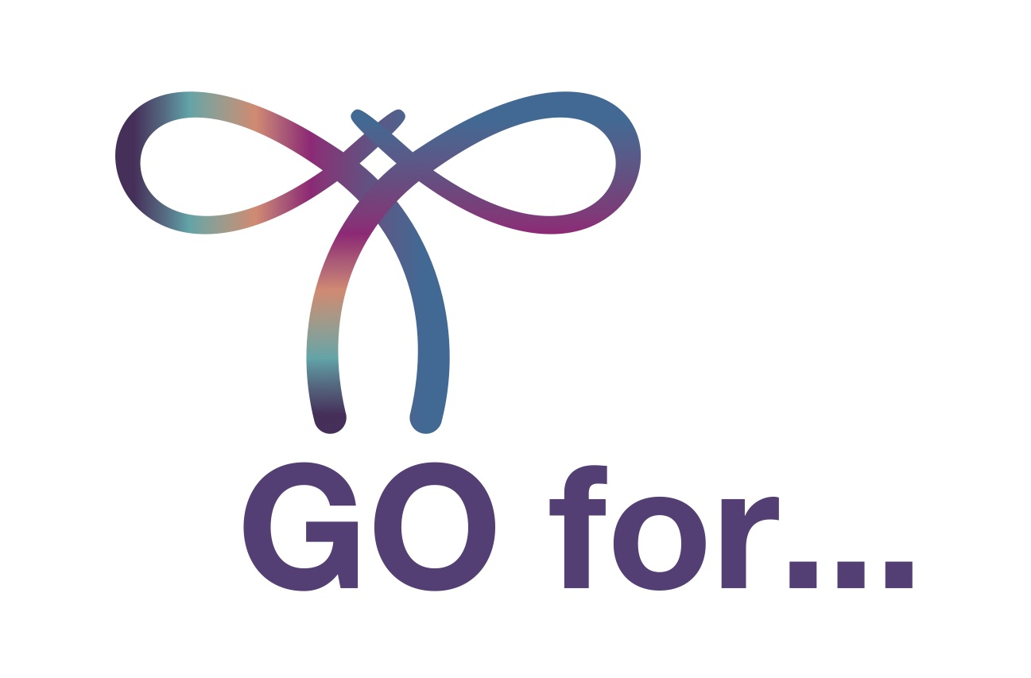
PRESS RELEASE: FOR IMMEDIATE RELEASE

World Gynecologic Oncology Awareness Day
(World GO Day).
On September 20, 2020, we will turn the world purple.

World GO Day raises awareness about gynaecological cancers worldwide

Geneva, Switzerland, Sept. 11, 2020 – Cancer patient advocates and medical professionals in more than 20 countries are planning activities for World Gynecologic Oncology Day (World GO Day) this month. A project of the European Society of Gynaecological Oncology (ESGO) and the European Network of Gynaecological Cancer Advocacy Groups (ENGAGe), World GO Day raises awareness about a group of gynaecologic cancers that more than one million women are diagnosed with each year. The second annual World GO Day will take place Sunday, Sept. 20, 2020.

This year’s activities have been adapted for physical distancing and public safety in light of the COVID-19 situation in participating countries. For example, instead of the in-person sports activities promoting the first year’s “GO For…” campaign, this year more activities will rely on online outreach. “We are focusing on support through social media networks. Purple is the colour of the gynaecological cancer ribbon. We encourage people around the world to raise awareness about gynaecological cancers and supporting patients by wearing something purple or painting their lips or nails purple. Then, share the photos with us using the #GoForPurple hashtag on Facebook, Instagram, or Twitter on September 20,” explains Dr. Murat Gultekin, ENGAGe Co-Chair.

This year, World GO Day organisers wish to raise awareness especially about gynaecological cancer symptoms and HPV prevention, in concept with the World Health Organisation’s global strategy for eliminating cervical cancer. Early diagnosis is key for all gynaecological cancers. “We want people to know that having a regular check-up with your gynaecologist should be a priority,” says Icó Tóth, ENGAGe Co-Chair and a patient advocate.
Through social media campaigns, World GO Day is sharing educational information about the main types of gynaecological cancers: cervical, ovarian, uterine, vaginal, and vulvar. “Thanks to the support of the ESGO medical professionals, and listening to patient voices, ENGAGe can share the latest, most relevant and guaranteed knowledge about these diagnoses so that every woman in the world has the chance to have the right information at the right time,” says ESGO President Prof. Philippe Morice. “I very much appreciate the effective cooperation of doctors and patients,” he says.
In addition to the hashtag #GoForPurple, pictures and messages will be shared using the hashtags #WorldGODay and #GoForCheckup to create a global conversation about gynaecological cancers. Information will also be published on the World GO Day website at www.worldgoday.org. Any group or individual can add a World GO Day activity on this website. “Let’s turn the globe purple together!” Tóth says.

About Gynaecologic Cancers
Over 1.3 million women worldwide were diagnosed with gynaecologic cancers in 2018: approximately 44% with cervical cancer, 23% ovarian cancer, 29% endometrial cancer, and less than 5% with other gynaecologic cancers, i.e., vulvar and vaginal cancers. Europe accounted for 21% of the world’s new cases in 2018.

In 2018, 468,000 women worldwide died from gynaecologic cancers.
Cervical cancer accounted for 67% of these cancer cases; counting approximately 311,000 deaths in 2018.

Some gynaecologic cancers can be prevented.
Regular screening and examinations, as well as lifestyle choices, can increase the chance of prevention or even early diagnosis of gynaecologic cancers when treatment can be more effective, and a complete cure is possible.
Although cervical cancer is preventable and can be cured if diagnosed at an early stage with HPV testing and regular Pap smear screening, 7 out of 10 women avoid being examined because they worry they might have the HPV virus.

Ovarian, uterine, cervical, and other gynaecologic cancers are among the most common cancers affecting women, but the awareness of these cancers in the general public is still significantly low.

Cervical Cancer Key Facts & Figures
- Among cancers affecting women, cervical cancer ranks only fourth to breast cancer.
- It is a preventable disease, but it accounted in 2018 for 570,000 newly diagnosed cases and 311,000 deaths worldwide.
- In the EU, every hour, two women lose their lives as a result of cervical cancer.
- Vaccines against the human papillomavirus (HPV), the primary causative agent of cervical cancers, are effective against 70%–80% of all oncogenic HPV types and have a tremendous potential impact for the new generation.
- The uptake rates of cervical cancer screening methods to reduce its incidence remain persistently below 80% even in developed countries.
ESGO and ENGAGe believe that increasing public awareness of gynaecological cancer prevention will ultimately make a difference in cancer survival rates.

About ENGAGe
Established in 2012 by ESGO, the European Network of Gynaecological Cancer Advocacy Groups (ENGAGe) represents advocacy groups of patients affected by all types of gynaecologic cancers, from the rarest to the most common, in particular: ovarian, endometrial, cervical, vulvar and rare cancers.

ENGAGe is the voice of gynaecologic cancer patients in Europe.
With over 50 gynaecologic cancer advocacy groups in 25 countries, ENGAGe is Europe’s largest network.

About ESGO
ESGO is Europe's foremost organization in gynaecologic cancers, dedicated to improving the health and well-being of women with gynaecological cancers through prevention, research, excellence in care and education.
Since its foundation in 1983, ESGO is a growing not-for-profit organization and forum of more than 2,500 professionals from over 40 countries around the world, leading the way to advancing the highest quality of care for women with gynaecologic cancers.

Acknowledgements
ESGO and ENGAGe gratefully acknowledge the generous support provided by the following sponsors of the World GO Day 2020:

Genmab, Seattle Genetics, GSK, Abviris, Karyopharm Therapeutics.

Media Contact
Icó Tóth, ENGAGe Co-Chair
Email: worldgoday@esgo.org

