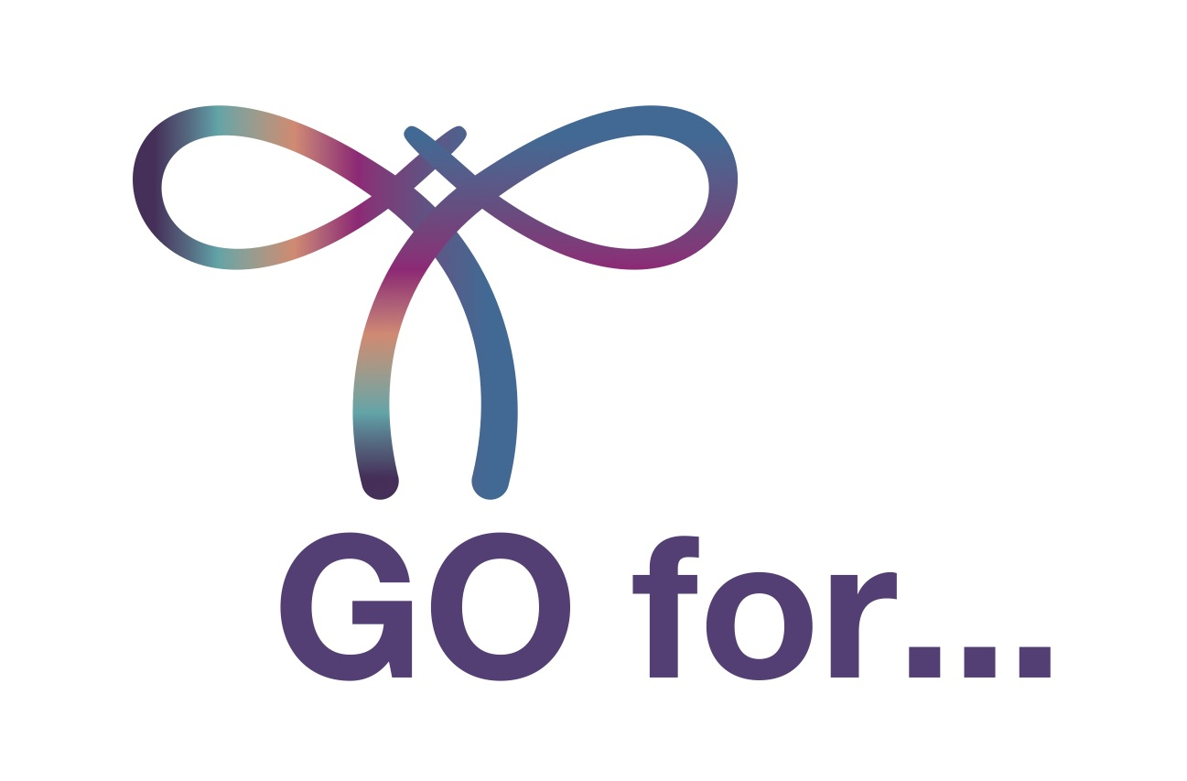
PRESS RELEASE: FOR IMMEDIATE RELEASE

World Gynecologic Oncology Awareness Day (World GO Day).

On September 20, 2021, doctors and patients unite to raise awareness about gynaecological cancers.

XX, XX, September XX, 2021 – The time has come to prepare for the third World GO Day celebration. Once again, people in more than 25 countries, including thousands of patients and dozens of groups of medical professionals and experts, will together support a single goal—raising awareness of gynaecologic cancers. More than one million women are diagnosed with these cancers annually. This year, World GO Day will take place Monday, September 20, 2021. This year’s message is simple: Information is power, but communication is the solution!

The theme for 2021 is communication between patients and doctors, represented by the main event hashtag #GOforcommunication.

“Information is power, but communication is the solution. It goes hand in hand with the very short but clear message: Talk to your doctor, do not be afraid to seek information on gynaecological cancers and to have your regular check-ups to prevent cancer. That is why #GOforprevention will be the second main hashtag of World GO Day,” says Prof. Murat Gultekin, who is the co-chair of the organisation that founded the event, the European Network of Gynaecological Cancer Advocacy Groups (ENGAGe).

To illustrate this communication, the event branding this year will feature two colours: purple representing gynaecological cancer patients from the World GO Day logo, and orange from the logo of the European Society of Gynaecological Oncologists (ESGO), ENGAGe’s parent group.

Planned activities this year include yoga, bike riding, pétanque, meditation sessions, and walks with caregivers, health workers, survivors, and supporters. These events are designed to raise awareness about gynaecological cancers, motivate people to go for preventative screenings, and invite all women to become more informed about cancer signs and symptoms and to talk to their doctors about their health.

Awareness is important because an early diagnosis is key for good treatment of gynaecological cancers. “We want people to know that having a regular check-up with your gynaecologist should be a priority. But also, ask the right questions. Be open in communication with your doctor. Asking about things that are not clear to us and pointing out even seemingly small symptoms can help get an accurate diagnosis,” explains ENGAGe Co-chair Icó Tóth.

In addition to the in-person and online events on September 20, the public can take part in World GO Day by wearing something purple or painting their lips or nails purple and sharing a photo online using the event hashtags.

“Our goal is to create a truly global initiative that reaches more and more countries, more patients, more doctors and experts every year and thus achieves global results in the field of prevention of gynaecological cancers,” says ESGO President Prof. Philippe Morice. “I am really happy that every year we have bigger impact and World GO Day can be really useful in cooperation of doctors and patients,” Morice says.

In addition to the hashtags #GOforcommunication and #GOforprevention, pictures and messages will be shared using the hashtag #WorldGODay to create a global conversation about gynaecological cancers. Information will also be published on the World GO Day website at www.worldgoday.org. Any group or individual can add a World GO Day activity on the website.

JOIN US AND CELEBRATE WORLD GO DAY 2021! TAKE PART AND HELP ORANGE MEET PURPLE.

Media Contact
Icó Tóth, ENGAGe Co-Chair
Email: worldgoday@esgo.org
https://www.worldgoday.org/campaign-2021

About Gynaecologic Cancers

Over 1.3 million women worldwide were diagnosed with gynaecologic cancers in 2020: approximately 44% with cervical cancer, 23% ovarian cancer, 29% endometrial cancer, and less than 5% with other gynaecologic cancers, i.e., vulvar and vaginal cancers. Europe accounted for more than 20% of the world’s new cases in 2020. In 2020, 420,000 women worldwide died from gynaecologic cancers.

Some gynaecologic cancers can be prevented. Regular screening and examinations, as well as lifestyle choices, can increase the chance of prevention or even early diagnosis of gynaecologic cancers when treatment can be more effective and a complete cure is possible. Although cervical cancer is preventable and can be cured if diagnosed at an early stage with HPV testing and regular Pap smear screening, 7 out of 10 women avoid being examined because they worry they might have the HPV virus.

Ovarian, uterine, cervical, and other gynaecologic cancers are among the most common cancers affecting women, but the awareness of these cancers in the general public is still significantly low.
Cervical Cancer Key Facts & Figures
- Among cancers affecting women, cervical cancer ranks only fourth to breast cancer.
- It is a preventable disease, but it accounted in 2020 for 420,000 deaths worldwide.
- In the EU, every hour, two women lose their lives as a result of cervical cancer.
- Vaccines against the human papillomavirus (HPV), the primary causative agent of cervical cancers, are effective against 70%–80% of all oncogenic HPV types and have a tremendous potential impact for the new generation.
- The uptake rates of cervical cancer screening methods to reduce its incidence remain persistently below 80% even in developed countries.
ESGO and ENGAGe believe that increasing public awareness of gynaecological cancer prevention will ultimately make a difference in cancer survival rates.

About ENGAGe

Established in 2012 by ESGO, the European Network of Gynaecological Cancer Advocacy Groups (ENGAGe) represents advocacy groups of patients affected by all types of gynaecologic cancers, from the rarest to the most common, in particular: ovarian, endometrial, cervical, vulvar and rare cancers.

ENGAGe is the voice of gynaecologic cancer patients in Europe.
With over 50 gynaecologic cancer advocacy groups in 25 countries, ENGAGe is Europe’s largest network.

About ESGO
ESGO is Europe's foremost organization in gynaecologic cancers, dedicated to improving the health and well-being of women with gynaecological cancers through prevention, research, excellence in care and education.
Since its foundation in 1983, ESGO is a growing not-for-profit organization and forum of more than 2,500 professionals from over 40 countries around the world, leading the way to advancing the highest quality of care for women with gynaecologic cancers.

Acknowledgements
ESGO and ENGAGe gratefully acknowledge the generous support provided by the following sponsors of the World GO Day 2021:
Genmab, Seattle Genetics, GSK, Abviris, Karyopharm Therapeutics.

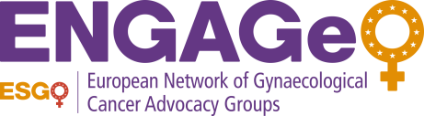

ESGO is Europe's foremost organization in gynaecologic cancers, dedicated to improving the health and well-being of women with gynaecological cancers through prevention, research, excellence in care and education. www.esgo.org

