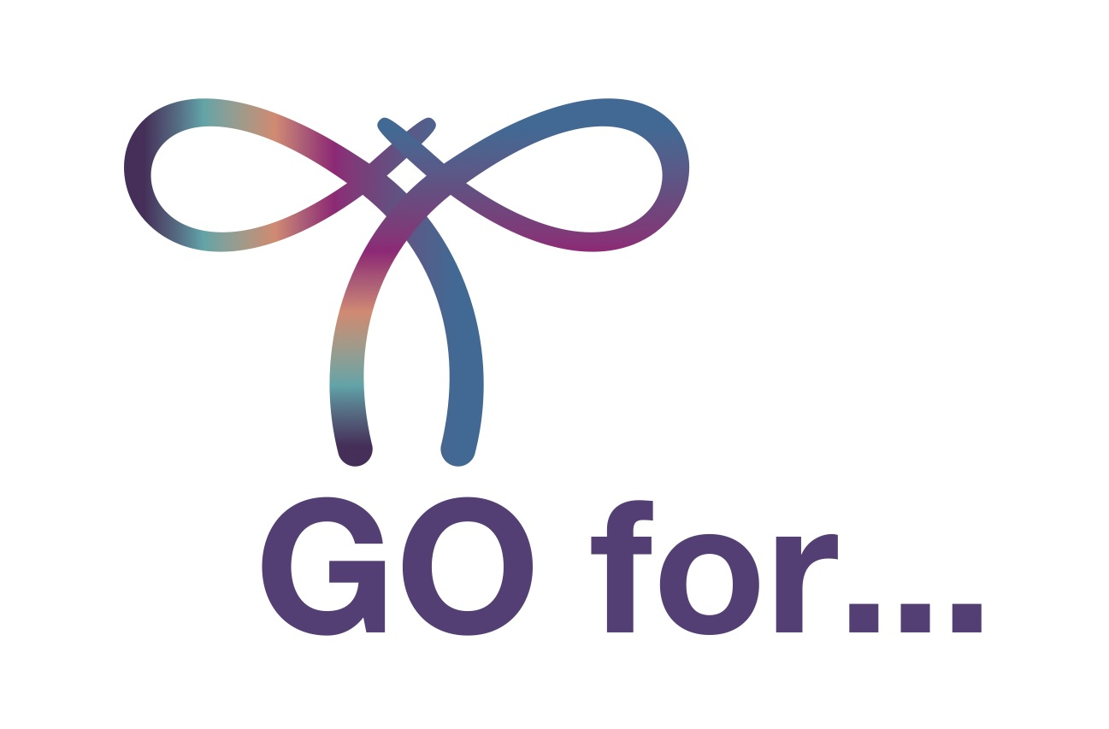
PRESS RELEASE: FOR IMMEDIATE RELEASE
World Gynecologic Oncology Awareness Day (World GO Day).

On September 20, 2022, turn the globe purple!

XX, September XX, 2022 – The 4th World GO Day is here. Across more than 25 countries, thousands of patients will come together with over 60 health organisations, groups of medical professionals and experts to support one goal: raising awareness about a group of gynaecological cancers that more than one million women are diagnosed with each year. In 2022, we’re focusing on endometrial cancer, and our main theme is choosing a healthy lifestyle and staying physically active, as key prevention strategies against endometrial cancer. So, GO for a Healthy Lifestyle. GO for Prevention. World GO Day 2022 is here.
To celebrate World GO Day this year, we’re planning plenty of outdoor activities for everyone under one banner: the Go for action challenge. “The goal of our challenge is simple: to inspire and motivate women all around the world to improve their health by incorporating regular physical activity into their daily routine, for instance, by Nordic walking, light jogging, swimming, cycling, whatever they enjoy! There are lots of activities to try – regardless of your age and physical fitness,” said Nicole Concin, President of European Society of Gynaecological Oncology (ESGO).

JOIN US AND CELEBRATE WORLD GO DAY 2022! TURN THE GLOBE PURPLE.
“Today thanks to our better scientific understanding, new surgical and medical therapy options are changing the standard of care for women with endometrial cancer. Nevertheless, many women don’t have access to these innovations, so we want to use World GO Day to increase awareness,” explained ENGAGe Co-Chair Jalid Sehouli.
“Choosing a healthy lifestyle with enough physical activity is one of the most important things you can do to avoid health issues, including cancer, especially endometrial cancer. This message goes hand in hand with all we’ve learned from World GO Day in previous years: Talk to your doctor, don’t be afraid to ask for information about gynaecological cancers and get regular preventive checkups,” said ENGAGe Co-chair Petra Adámková.
Ovarian, uterine (endometrial), cervical and other gynaecological cancers are among the most common cancers affecting women. But women themselves often don’t know the symptoms or may be too embarrassed to consult their doctor. “The incidence of endometrial cancer is rising. Lifestyle and genetics can affect the risk of developing endometrial cancer. We’d therefore like to use World GO Day to raise awareness and highlight the importance of physical activity, nutrition and genetic counseling,” added Jalid Sehouli.

Media Contact
Petra Adámková, Co-chair & WGOD project manager
Email: worldgoday@esgo.org
www.worldgoday.org

About Gynaecological Cancers

Over 1.3 million women worldwide were diagnosed with gynaecological cancers in 2020: of these, approximately 44% were cervical cancer, 29% endometrial cancer, 23% ovarian cancer and less than 5% other gynaecological cancers, i.e. vulvar and vaginal cancers. Europe accounted for more than 20% of the new cases globally. In 2020, 420,000 women worldwide died from gynaecological cancers.

Some gynaecological cancers can be prevented. Regular screening and examinations along with lifestyle choices can help reduce risk factors and even promote early diagnosis at a stage when treatment can be more effective and a complete cure is possible. Although cervical cancer is preventable and can be cured if diagnosed early through HPV testing and regular pap smear screenings, 7 out of 10 women avoid these examinations because of fear they might have the HPV virus.

Ovarian, uterine, cervical and other gynaecological cancers are among the most common cancers affecting women, but public awareness of these cancers remains worryingly low.

ESGO and ENGAGe believe that raising public awareness about gynaecological cancer prevention will ultimately improve survival rates.

About ENGAGe
Established in 2012 by ESGO, the European Network of Gynaecological Cancer Advocacy Groups (ENGAGe) represents advocacy groups of patients affected by all types of gynaecological cancers, from the rarest to the most common, in particular: ovarian, endometrial, cervical, vulvar and rare cancers.

ENGAGe is the voice of gynaecological cancer patients in Europe. With over 70 groups in 25 countries, ENGAGe is Europe’s largest gynaecological cancer patient advocacy network.

About ESGO
ESGO is Europe's foremost gynaecological cancer organisation dedicated to improving the health and well-being of women with gynaecological cancers through prevention, research and excellence in care and education.

Since its foundation in 1983, ESGO has been a growing not-for-profit organisation and forum of more than 2,500 professionals from over 40 countries around the world, leading the way in advancing the highest quality of care for women with gynaecological cancers.

Acknowledgements
ESGO and ENGAGe gratefully acknowledge the generous support of the following sponsors of World GO Day 2022:

Astra Zeneca, GSK, MSD Vaccines, Novocure, SeaGen, Sophia Genetics

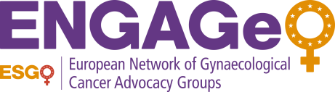

ESGO is Europe's foremost gynaecological cancer organisation dedicated to improving the health and well-being of women with gynaecological cancers through prevention, research and excellence in care and education.
Established in 2012 by ESGO, the European Network of Gynaecological Cancer Advocacy Groups (ENGAGe) represents the advocacy groups of patients affected by all types of gynaecological cancers.

