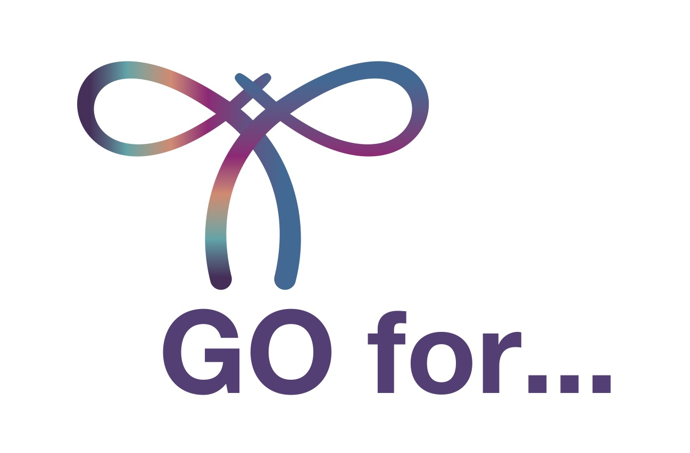
PRESS RELEASE: FOR IMMEDIATE RELEASE
World Gynecologic Oncology Awareness Day (World GO Day).

On September 20, 2023, Join us for #WorldGODay!

XX, XY XX, 2023 – On the 5th World Gynecologic Oncology Day, patient advocates around the globe will unite to raise awareness about the importance of testing for gynecologic cancers and their risk factors. World GO Day is a unique opportunity to educate people worldwide about the importance of sharing information about symptoms, treatment, prevention and, especially, testing.
GO for Testing. GO for Prevention. GO for the Right Treatment. World GO Day 2023 is here!
This year’s campaign focuses on two types of testing:

- Genetic testing
- HPV testing

Genetic testing can be very useful for risk assessment of developing certain types of cancer and making the best treatment decisions. Most gynecological cancers arise spontaneously and are not hereditary. However, certain ones are caused by errors in genetic material which may run in the family. Therefore, some gene mutations increase the risk of developing cancer, such as ovarian and endometrial cancer. “Genetic testing has traditionally been offered to individuals with a strong family history of cancer. But using family history alone may miss identifying several gene carriers. This is the main reason why all women with gynecological cancers should now be offered genetic testing,” said prof. Nicole Concin, President of the European Society of Gynaecological Oncology (ESGO).

The human papillomavirus (HPV) is the most common sexually transmitted infection and HPV is responsible for a considerable number of genital cancers. Certain types of so-called high-risk HPV-types are a major cause of cervical cancer. Knowing more about HPV is essential for all of us, and HPV testing gives us an opportunity to prevent cancer. Nevertheless, the interpretation and follow up should be performed by experienced gynecologists to avoid under- and overtreatment. “Because the infection of HPV normally has no symptoms, without periodic testing these transforming infections cannot be detected and may eventually lead to cancer,” Concin added.
The aim of the 5th World GO Day is to draw special attention to genetic and HPV testing. In addition, World GO Day promotes being attentive to overall health in combination with a healthy lifestyle (e.g., smoking) since these are key prevention strategies against gynecological cancers.

In 2023, World GO Day will open discussions about five types of gynecological cancers: cervical, ovarian, uterine (endometrial), vulvar and vaginal. In connection with these, we’ll also focus on 5 basic tips for an active, happy, healthy life: the aforementioned importance of genetic and HPV testing, mental health, regular physical activities, and healthy food. World GO Day organizers are also preparing new physical activities to observe the awareness day this year. As in past years, there will be plenty of outdoor activities and also an indoor activity, inspired by taste, to promote healthy food. “The goal of our new initiative is simple: to inspire and motivate women all around the world to improve their daily menu by incorporating healthy food in it. And sharing their recipes and tips with each other. Food is an important addition to regular physical activity like Nordic walking, light jogging, swimming, cycling—whatever—that everybody enjoys!” Concin said.

JOIN WORLD GO DAY 2023! TURN THE GLOBE PURPLE AND GO FOR TESTING.
Since 2019, over 80 organizations from 34 countries have engaged in more than 130 activities to raise awareness about cervical, ovarian, endometrial, and rare gynecologic cancers. World GO Day aims to support women fighting these diseases and educate about the importance of prevention and right treatment.

On September 20, thousands of patients and patient advocates will come together to support the World GO Day goal: raising awareness about a group of gynecological cancers that more than one million women are diagnosed with each year. Everyone can get involved!

#GOforTesting #GOforPrevention
#GOforPurple #WorldGODay

Quotes
1.
“Today, we have several new innovative treatment options for women with gynecological cancers. And most importantly, new testing options that can detect problems early and allow tailored therapies to improve the prognosis of our patients. Yet many women are not well informed about these new developments, so we want to use World GO Day to raise awareness and to strengthen the patient’s empowerment,” explained ENGAGe Co-Chair and ESGO council member Jalid Sehouli.

2.
“A healthy lifestyle and diet with plenty of physical activity and mental well-being is one of the most important things you can do to avoid health problems, including cancer. This year, we also want to point out a fact that requires a great deal of personal courage. Get tested. Don’t be afraid and do go for testing. Talk to your doctor, ask for information about gynecologic cancers, and go for regular preventive screenings and gene testing, if relevant in your case,” said ENGAGe Co-chair Petra Adámková.

3.
“Gynecological cancers are among the most common cancers affecting women. Nevertheless, many women are not adequately informed by their doctors about the opportunities for prevention and screening. Please, ask you doctors proactively. We would like to use World GO Day to raise awareness and highlight the importance of physical activity, healthy diet, regularly check-ups and expert opinions,” underlined ENGAGe Co-Chair Jalid Sehouli.

Media Contact
Petra Adámková, ENGAGe Co-chair & WGOD project manager
Email: worldgoday@esgo.org
www.worldgoday.org

About Gynaecological Cancers
Over 1.3 million women worldwide were diagnosed with gynaecological cancers in 2020: of these, approximately 44% were cervical cancer, 29% endometrial cancer, 23% ovarian cancer and less than 5% other gynaecological cancers, i.e., vulvar and vaginal cancers. Europe accounted for more than 20% of the new cases globally. In 2020, 420,000 women worldwide died from gynaecological cancers.

Some gynaecological cancers can be prevented. Regular screening and examinations along with lifestyle choices can help reduce risk factors and even promote early diagnosis at a stage when treatment can be more effective, and a complete cure is possible. Although cervical cancer is mostly preventable and can be cured if diagnosed early through screenings, 7 out of 10 women avoid these examinations because of fear they might have the HPV virus.

Ovarian, endometrial, cervical, and other gynaecological cancers are among the most common cancers affecting women, but public awareness of these cancers remains worryingly low. ESGO and ENGAGe believe that raising public awareness about gynaecological cancer prevention will ultimately improve survival rates.

About ENGAGe
Established in 2012 by ESGO, the European Network of Gynaecological Cancer Advocacy Groups (ENGAGe) represents advocacy groups of patients affected by all types of gynaecological cancers, from the rarest to the most common, in particular: ovarian, endometrial, cervical, vulvar and rare cancers. With over 70 groups in 25 countries, ENGAGe is Europe’s largest gynaecological cancer patient advocacy network.

About ESGO
ESGO is Europe's foremost gynaecological cancer organisation dedicated to improving the health and well-being of women with gynaecological cancers through prevention, research and excellence in care and education. Since its foundation in 1983, ESGO has been a growing not-for-profit organisation and forum of more than 2,500 professionals from over 40 countries around the world, leading the way in advancing the highest quality of care for women with gynaecological cancers.

Acknowledgements
ESGO and ENGAGe gratefully acknowledge the generous support of the following sponsors of World GO Day 2023: Astra Zeneca, GSK, MSD vaccines, Novocure.

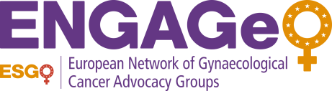

ESGO is Europe's foremost gynecological cancer organization dedicated to improving the health and well-being of women with gynecological cancers through prevention, research and excellence in care and education.
Established in 2012 by ESGO, the European Network of Gynaecological Cancer Advocacy Groups (ENGAGe) represents the advocacy groups of patients affected by all types of gynecological cancers.
Established in 2012 by ESGO, the European Network of Gynaecological Cancer Advocacy Groups (ENGAGe) represents the advocacy groups of patients affected by all types of gynaecological cancers.

